Kingdom of Saudi Arabia

Ministry of Education

Imam Abdulrahman bin Faisal University

College of Science and Humanities

Computer Science department

**BLACK PLATE RESTURANT**

*“*OBJECT ORIENTED PROGRAMMING 2*”*

**By:**

Bushra Alshehri – 2200004242

Jumana Aljassim –2200006296

Asma Alshehri – 2200000484

Manar Alenzi – 2200006162

Database & Queries:

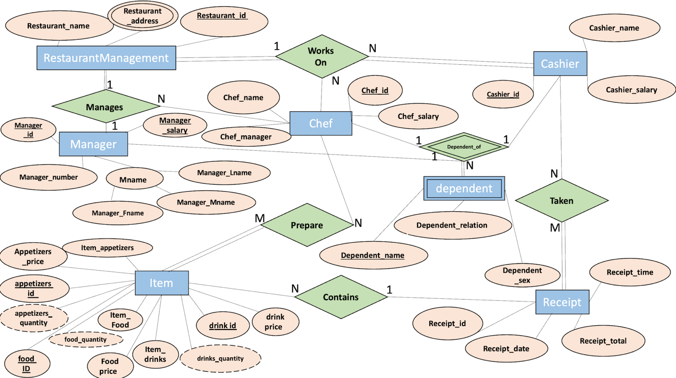

Application's GUI Design:

Black plate restaurant interface:

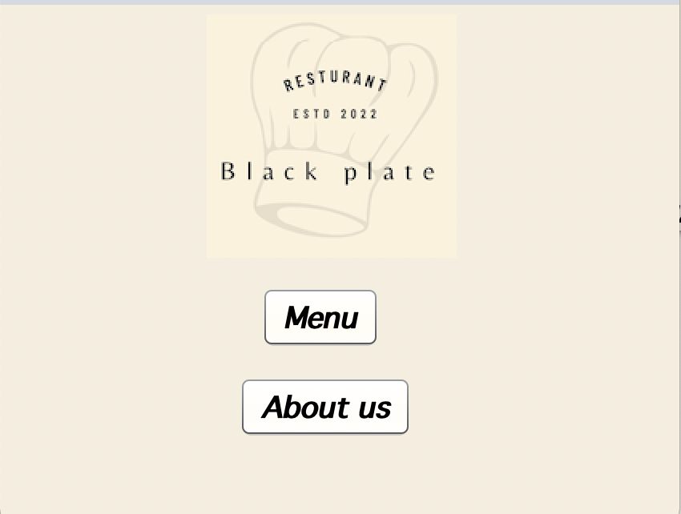

If you press on Menu:

Save Receipt: It will save it in data base.

New Receipt: Refresh the page.

Go Back: To the main interface.

Pay:

If you press on about us:

Go Back: To the main interface.

Classes Hierarchy:

Manager

Cashier

